**Building a Die Roll Simulator**

**Building the Circuit**

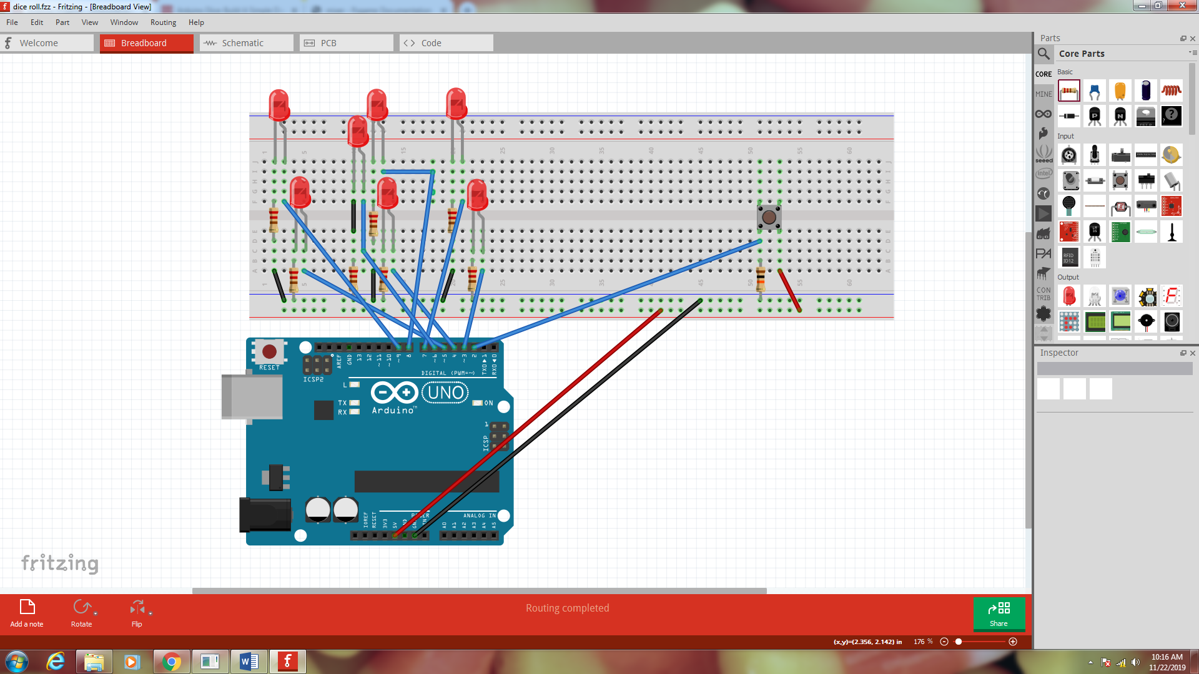

**The Code**

int button = 2;

//LED for DICE

int bottomLeft = 3;

int middleLeft = 4;

int upperLeft = 5;

int middle = 6;

int bottomRight = 7;

int middleRight = 8;

int upperRight = 9;

int state = 0;

long randNumber;

//Initial setup

void setup(){

pinMode(bottomLeft, OUTPUT);

pinMode(middleLeft, OUTPUT);

pinMode(upperLeft, OUTPUT);

pinMode(middle, OUTPUT);

pinMode(bottomRight, OUTPUT);

pinMode(middleRight, OUTPUT);

pinMode(upperRight, OUTPUT);

pinMode(button, INPUT);

Serial.begin(9600);

randomSeed(analogRead(0));

}

void loop(){

//Read our button if high then run dice

if (digitalRead(button) == HIGH && state == 0){

state = 1;

randNumber = random(1, 7);

delay(100);

Serial.println(randNumber);

if (randNumber == 6){

six();

}

if (randNumber == 5){

five();

}

if (randNumber == 4){

four();

}

if (randNumber == 3){

three();

}

if (randNumber == 2){

two();

}

if (randNumber == 1){

one();

}

delay(4000);

clearAll();

state = 0;

}

}

void six()

{

digitalWrite(bottomLeft, HIGH);

digitalWrite(middleLeft, HIGH);

digitalWrite(upperLeft, HIGH);

digitalWrite(bottomRight, HIGH);

digitalWrite(middleRight, HIGH);

digitalWrite(upperRight, HIGH);

}

//Add functions for other numbers one() , two(), three(), four(), and five()

Finally, you will need a clearAll() function

void clearAll()

{

digitalWrite(bottomLeft, LOW);

digitalWrite(middleLeft, LOW);

digitalWrite(upperLeft, LOW);

digitalWrite(bottomRight, LOW);

digitalWrite(middleRight, LOW);

digitalWrite(upperRight, LOW);

digitalWrite(middle, LOW);

}